* LLD has 3 key features
  + Scalability
  + Maintainability (easy to debug)
  + Re-usability (loosely coupled)
* HLD:
  + Tech stack
  + DB (relational/non-relational/both)
  + Server scale
  + Cost optimization
* In simple terms:
  + HLD: System Architecture
  + LLD: Code Architecture
  + DSA: Algorithms
* Abstraction
  + It is to hide the methods which are not required to the client
  + The client can see the methods (non-vulnerable) but it doesn’t have to know it to use the class.
  + Ex: To drive a Car, the driver doesn’t need to know how the Engine works.
* Encapsulation
  + Write all the characteristics (variables) and behaviours (methods) in a capsule.
  + Here **data security** comes into picture, where properly the things are hidden that the client shouldn’t see.
  + **getters** and **setters** are highly preferable.
* Polymorphism
  + **Dynamic** (or Run-time) polymorphism: Method Overriding
  + **Static** (or Compile-time) polymorphism: Method Overloading
* **----- UML Diagram -----**
* It has 2 parts:
  + Structural
    - Static structure
    - Components & their links
    - Ex: **Class diagram**
  + Behavioral
    - Dynamic structure
    - Interaction between objects
    - Ex: **Sequence Diagram**
* **Class diagram**
* **Diagram rules**
  + Class is represented in vertical rectangle having 3 parts
    - Top: class name
    - Middle: characteristics (variables)
    - Bottom: behaviours (methods)
  + To represent access modifiers:
    - Public : **+**
    - Private:  **-**
    - Protected: **#**
  + If the class is abstract, then write **<<abstract>>** on the top of the rectangle.
  + 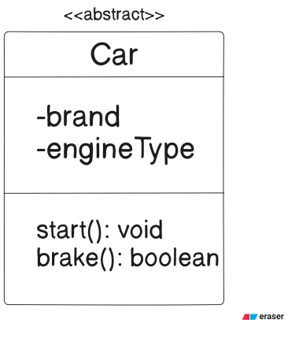
* **Associations**
* Types:
  + It is of 2 types:
    - Class Association
    - Object Association
  + **Class Association**
    - Inheritance
  + **Object Association**
    - Simple Association
    - Aggregation
    - Composition
* **Class Association**
  + **“is-a”** relationship
  + Let say, *Human* is inheriting *Animal* class: we can say *“Human* ***is-a*** *Animal”*
* **Object Association**
  + **Simple Association**
    - Definition: Basic relationship where 2 objects are connected; but **exist independently**.
    - Ownership: No ownership; neither controls life-cycle of others;
    - Example: *Teacher* associate with *Student*; both exist independently
    - Key point: Objects can exist without each other; the relationship just a link or usage.
    - Symbol:  or  (one to another)
    - 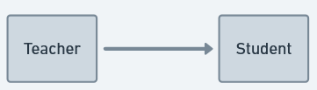
  + **Aggregation**
    - Definition: weak **“has-a”** relationship; one object (whole) contains/uses another object (part) but the part object can exist independently.
    - Ownership: **whole** ***owns* part**; but part’s lifecycle is independent.
    - Example: Library (whole) and Book (part); Book can exist independently
    - Key point: shared ownership; contained object (part) can exist independently of the container.
    - Symbol:  (diamond head; not filled)
      * diamond head will be towards *the whole*
    - 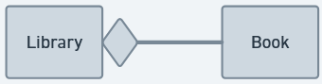
  + **Composition**
    - Definition: strong **“part-of”** relationship; one object (whole) exclusively ***owns*** other object (part)
    - Ownership: *the part*’s lifecycle is tied to *the whole*. If *the whole* is destroyed, *the part* will also be destroyed.
    - Example: *House* (whole) and *Room* (part); without House, Room will not exist.
    - Key Point: exclusive ownership; strong dependency;
    - Symbol:  (diamond head; filled)
      * diamond head will be towards *the whole*
    - 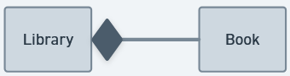
  + practically, only Composition exists;
  + in simple terms:
    - **Simple Association**: both **actually exists** independently. Both are **just linked**.
    - **Aggregation**: *the part* **can exist** independently; *the whole* **contains** *the part*
    - **Composition**: *the part* **cannot exist** independently; *the whole* is **made up of** *the part*.
* **Sequence diagram**
* Representation:
  + No need to represent a class with 3-level structure unlike Class diagram; just write class name inside a block.
  + Use arrow (one for unidirectional, 2 for bidirectional) to represent the relationship;
* Lifeline
  + Vertical line will be there for each object that represent how long the object is needed and then destroyed.
* Activation bar
  + Lifeline defines how long an object will exist; Activation bar represents how long an object will remain active.
* Messages
  + According to wait/not-wait
    - Async: send messages repeatedly without waiting for response.
      * Send message: solid **opened** arrow with <<message>>
    - Sync: send one message and wait for its response.
      * Send message: solid **closed** arrow with <<message>>
      * Response: dashed arrow with <<response>>
  + According to lifeline 2 types of messages:
    - **Create** : to create a object (start lifeline): solid **closed** arrow with <<create>>
    - **Destroy** : to destroy a object (end lifeline): solid **closed** arrow with <<destroy>>
  + According to reach-ability, 2 types of messages: dot inside a circle with arrow
    - **Lost message**: the message couldn’t reach the destination
      * The destination object was inactive while sending message
      * 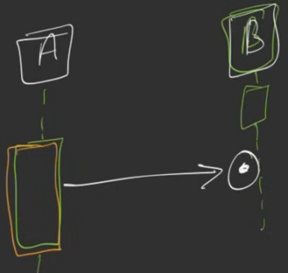
    - **Found message**: the sender of a message is lost.
      * The source object became inactive after sending message.
      * 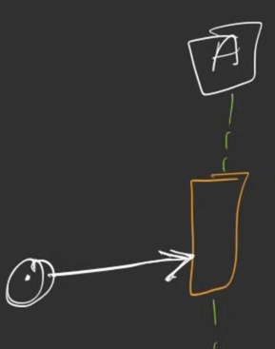
* 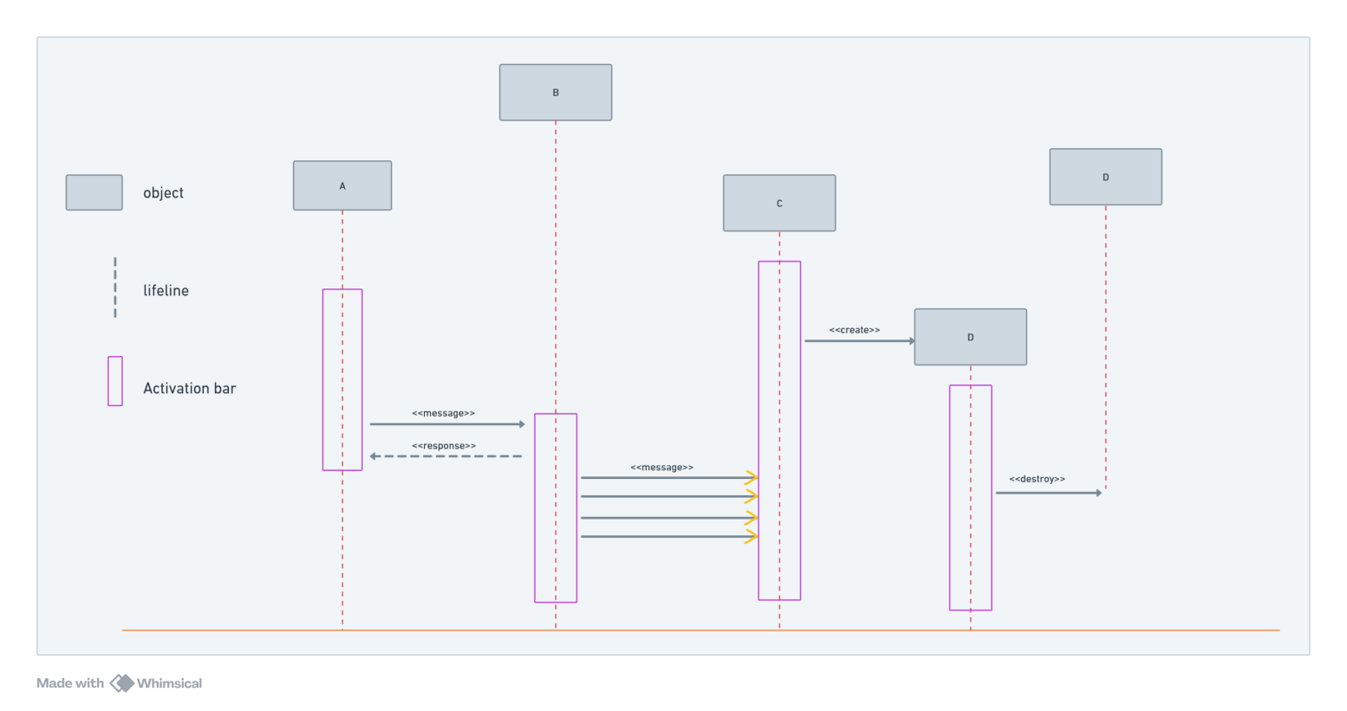
* Consider the below requirement
  + Use case
    - 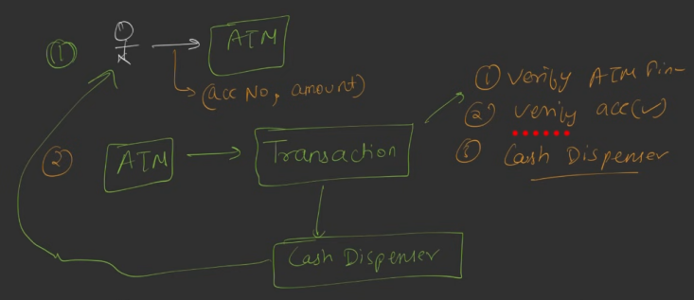
    - 1. User will go to ATM with *account number, amount*
    - 2. ATM will call transaction; it’ll do 3 checks: *verifyAtmPin, verifyAccount, cashDispenser*
    - 3. User will get the money.
  + Objects
    - Atm
    - User
    - Transaction
    - Account
    - Dispenser
  + Sequence Diagram
    - 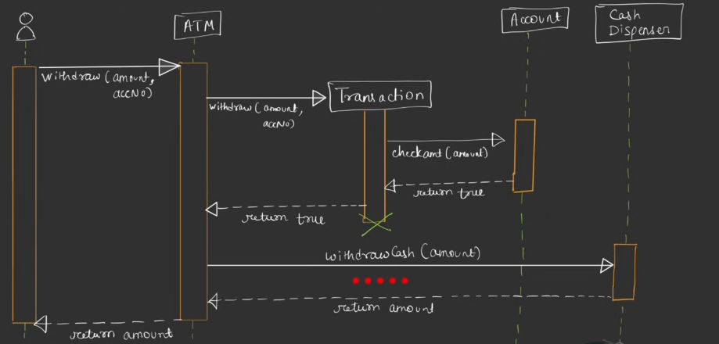(ignore those red dots)
    - Here, withdraw and return amount are synchronous <<message>> and <<response>> (from user to ATM)
    - ATM & Transaction
      * ATM to Transaction: **sync** <<create>> <<message>>
      * Transaction to ATM: **sync** <<response>>
    - Transaction & Account
      * Transaction to Account: **sync** <<message>>
      * Account to Transaction: **sync** **<<destroy>>**
    - ATM & Cash Dispenser
      * **Sync** <<message>> & <<response>>

**----- SOLID -----**

* **SOLID**
  + **Single Responsibility Principle (SRP)**
  + **Open-Close Principle (OCP)**
  + **Liskov Substitution Principle (LSP)**
  + **Interface Segregation Principle (ISP)**
  + **Dependency Inversion Principle (DIP)**
* **SRP (Single Responsibility Principle)**
  + One class should do only one thing or handle only one responsibility
  + *It doesn’t mean, one class should have one method only; it can have multiple methods but all those should do a single type of work.*
  + 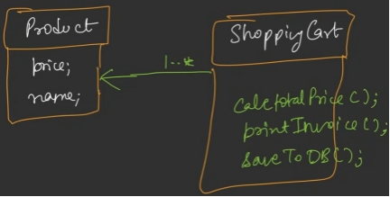
    - Here, *ShoppingCart* has too many responsibility like calculate total price, print invoice, save to DB.
    - If we want to change the DB saving mechanism, we’ll have to change this again which is not correct.
  + 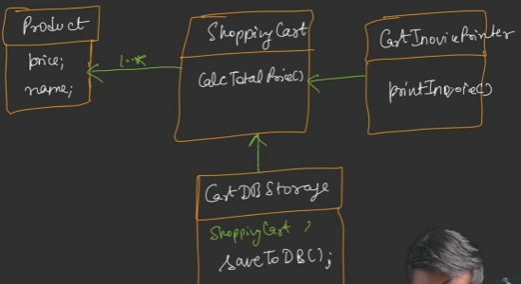
    - Here every class contains their own set of responsibility.
    - it is having “has-a” relationship.
* **OCP (Open-Close Principle)**
  + A class should be open for extension, but close for modification.
  + Use interface to define the methods, and use concrete classes implementing those interfaces to define those methods.
  + Use variable of type Interface and store objects of type Concrete class.
  + For example: DBStorage is a interface; DBStorageSQL, DBStorageMongoDB can be the concrete classes.
  + 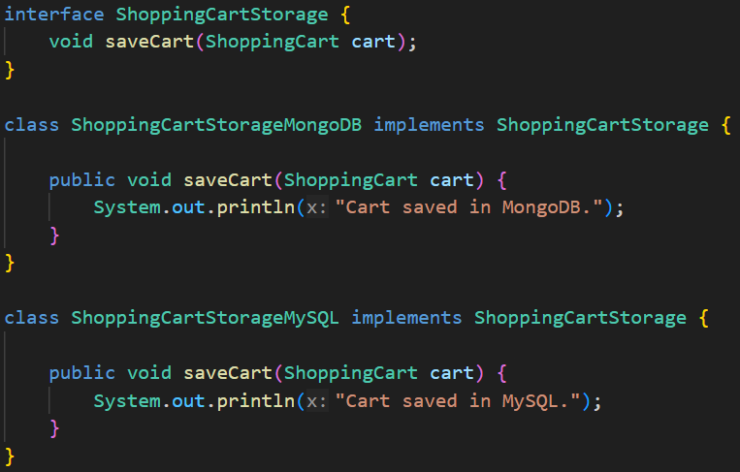
* **LSP (Liskov Substitution Principle)**
  + *Sub classes* should be substitutable for their *Base classes*.
  + Sub class: Child class; Base class: Parent class
  + Child class must contain all the methods present in Parent class/interface; Child class can have more methods but not less.
  + For example:
    - 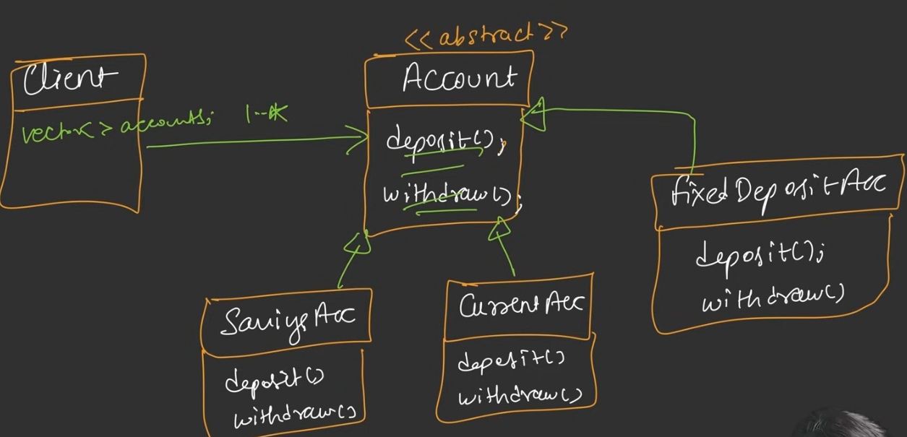
      * Here, FixedDepositeAccount cannot have *withdraw()* method, so normally we ***throw an exception*** in this method;
      * but client doesn’t know that withdraw() will give exception as it should be supported.
    - The below is the solution to this; there should be levels of the type of accounts.
    - 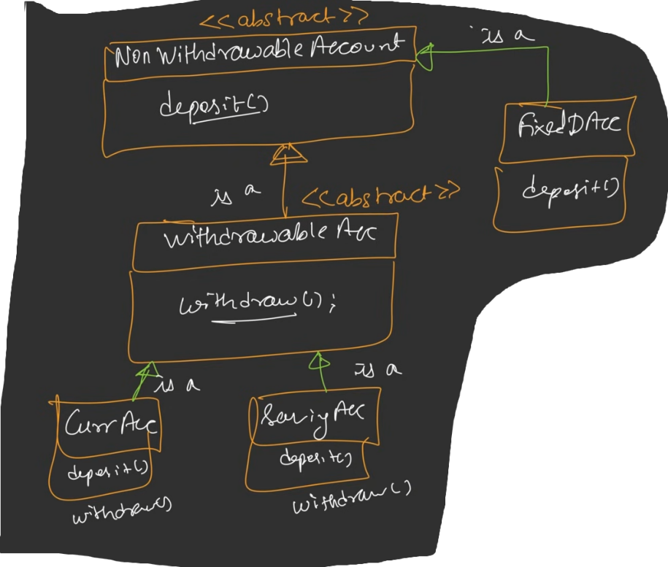
  + 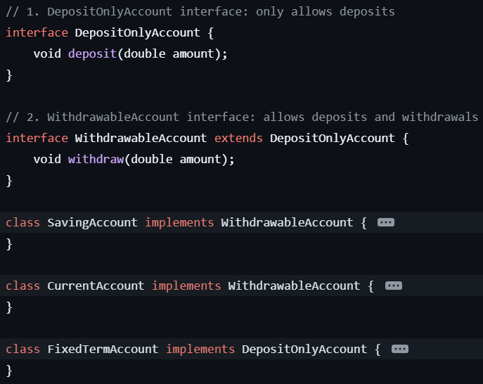
  + **Rules**
  + **Signature Rule**  (**broader**: parent of any level, **narrow**: child of any level)
    - **Method Argument Rule**
      * A subclass *must**not* **narrow** method parameters; it may accept the **same** or **broader** types.
        + Anyways it is not supported in any OOP language; you must write the same argument type as that of super class in case of method overriding.
      * Better to use a parent interface/class type as the method argument, so that whenever the object is passed, it can be either parent or child.
      * 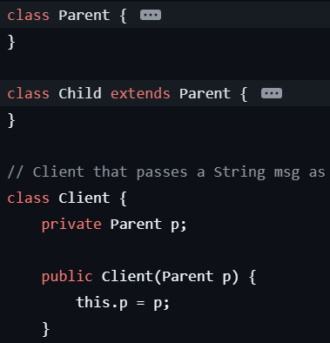
    - **Return Type Rule**
      * An overridden method *may return* the **same** or a **narrower** type.
        + It is also not supported in most OOP language. The return type should be same as its super class method in case of overriding.
    - **Exception Rule**
      * A subclass *may throw* the **same** or a **narrower** checked exception; *unchecked exceptions are unrestricted*.
    - One line rule: **Parameters → wider**, **Return → narrower**, **Exceptions → narrower**
  + **Property Rule**
    - **Class Invariant**
      * A subclass must preserve ALL invariants of its superclass.
      * Invariant is the custom rules for a class that it must follow.
      * Parent class:
        + 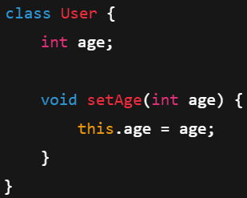
        + It requires the invariant **age >= 0**
      * Child class:
        + 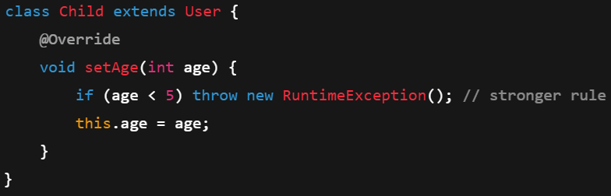
        + It demands **age >= 5** (broke parent’s invariant rule)
    - **History Constraint**
      * Subclass must allow what parent allows, and must not allow what parent forbids.
  + **Method Rules**
    - **Precondition**
      * Precondition means “What must be true before a method is called”
      * A subclass must **NOT strengthen** preconditions.
      * *Example:*Lets say one password validator method of parent class requires the minimum length should be *8*; its child class’s method can make its minimum length less than 8, but not greater.
    - **Postcondition**
      * Postcondition means “What is guaranteed after the method finishes”
      * A subclass must **NOT weaken** postconditions.
    - 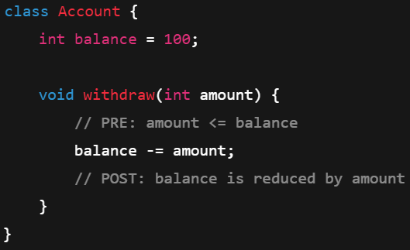
    - 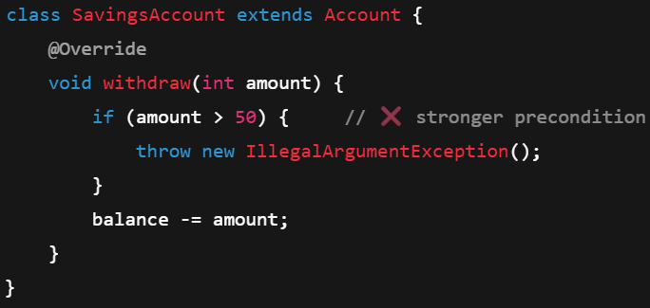(pre)
    - 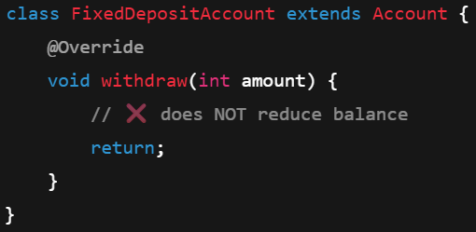(post)
  + **NOTE**
  + **invariant** and **history** are object level; **precondition** and **postcondition** are method level;
    - 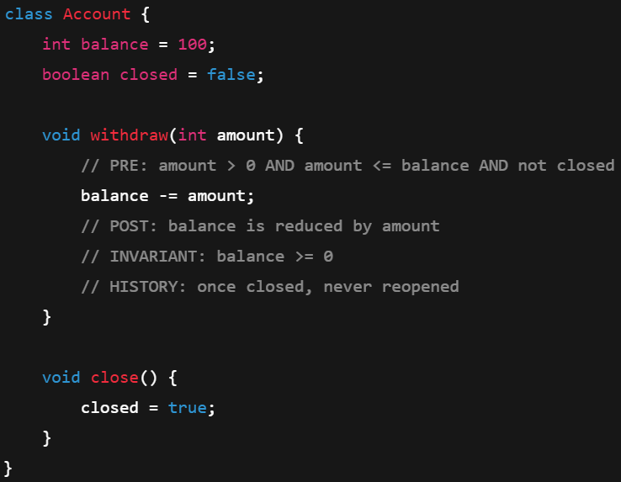
    - **Precondition**: can I call the method now? (amount <= balance)
    - **Postconditoin**: what does the method must guarentee after it runs? (balance reduce)
    - **Invariant**: is this object valid all the times? (balance >= 0)
      * In an account, balance cannot be less than 0 (assuming no minus balance account)
    - **History**: Can this state ever go backward? (OPEN → CLOSED; no reopen)
* **ISP (Interface Segregation Principle)**
  + Many small, focused interfaces are better than one big “fat” interface..
  + Clients should not be forced to depend on interfaces they do not use.
  + Bad design:
    - 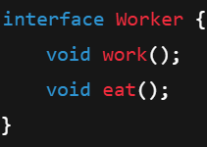
    - 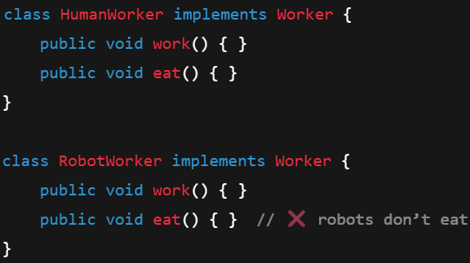
  + Good design:
  + 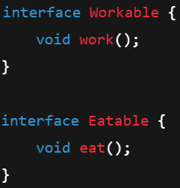
  + 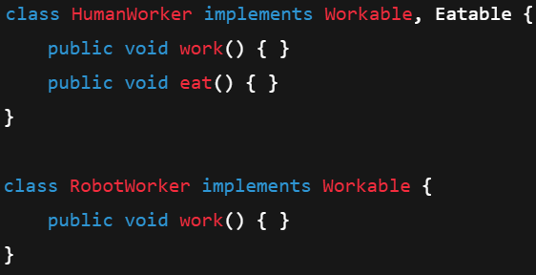
* **DIP (Dependency Inversion Principle)**
  + High-level code should depend on abstractions (interfaces), not on concrete implementations.
  + write concrete classes implementing the interfaces so that the code can be written **loosely-coupled**.
  + High level modules should not talk to the lower level modules directly; the communication should happen through an interface.
    - Ex: application wants to use DB, but it should not talk to SqlDB or MongoDB directly, it should talk to one interface to which both SqlDB and MongoDB implement.
* **NOTE** 
  + OCP and DIP looks same, but it is not;
  + DIP is a way to achieve OCP but these 2 are not same.
  + **To check OCP:** “To add a new feature, do I have to edit this existing class?”
  + **To check DIP:** “Does this high-level class depend on a concrete class or on an abstraction?”
  + Abstraction means ***interface*** or ***abstract class***.
  + Consider the below example:
    - 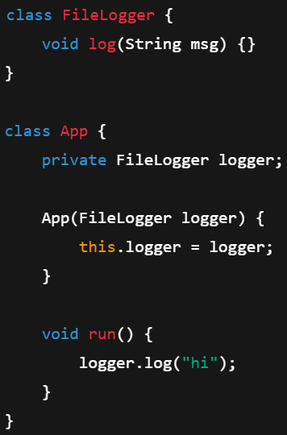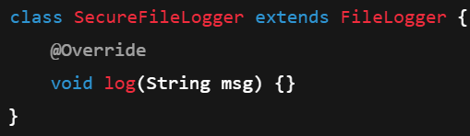
    - 
    - To scale it, Did we edit the existing code? **No,** we just created one class *SecuredFileLogger* inheriting the previous class. So **OCP satisfied**.
    - Does App depends on a concrete class? **Yes**, *FileLogger* is a concrete class; not an interface or abstract class; So, **DIP violated**
* How to write real-world code maintaining the SOLID principles?
  + Question 1: **If this file changes, will it change for ONE reason only?**
  + Question 2: **If I add a new feature, will I edit this class or add a new one?**
  + Question 3: **Can I replace a parent with a child and nothing breaks?**
  + Question 4: **Am I forced to implement methods I don’t use?**
  + Question 5: **Does my core logic depend on interfaces or concrete classes?**
* F

**Google Docs LLD with SOLID**

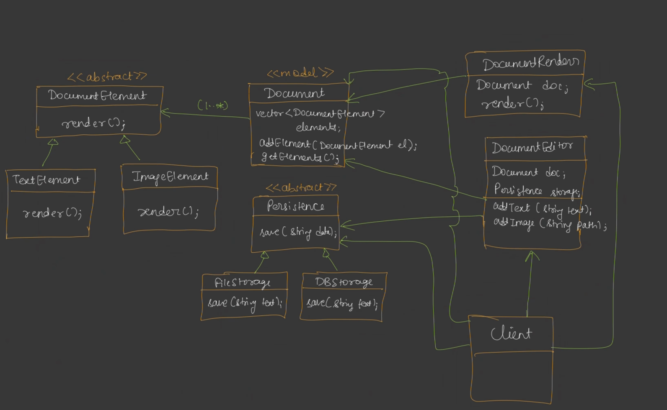

* F

**--- Stratagy Design Pattern ---**

* It is used to avoid Inheritance Hell.
* Separate “what changes” from “what stays the same”, and use composition instead of inheritance.
* *Inheritance* fixes behavior at **compile time**. *Strategy* lets behavior vary at **runtime**.
* Consider the below design:
  + 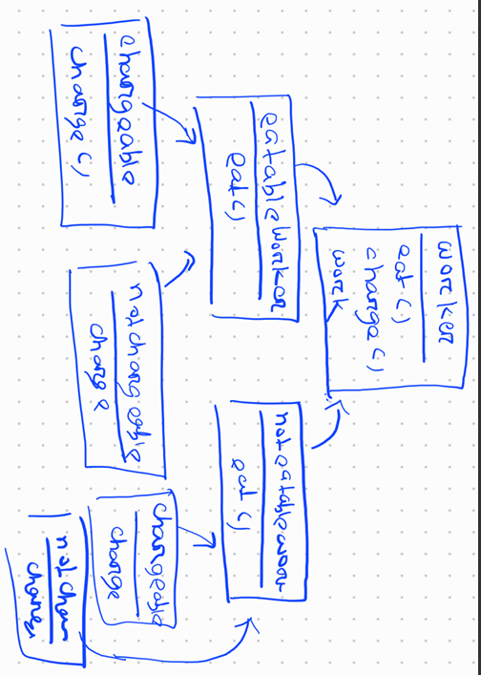
    - Here, for every type of changes in **eat()** and **charge()** method, one more class has to be created inheriting the parent one.
    - For each combination, we need to maintain; here **chargeable()** and **notchargeable()** are written 2 times to accommodate 2 types of **eatable()** and **noneatable()**
    - If more type of things come, then this inheritance will grow exponentially.
  + 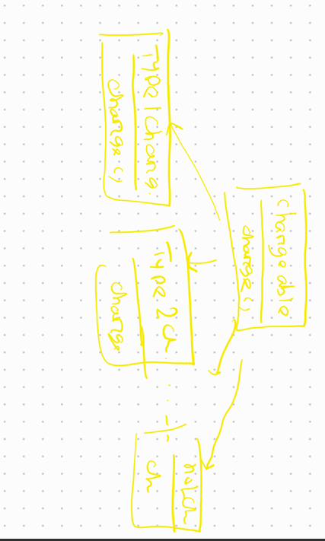
  + 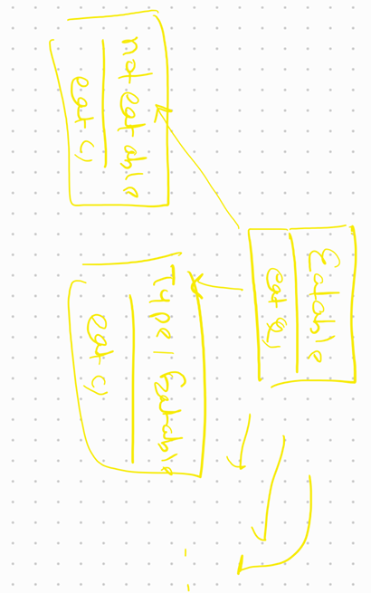
  + 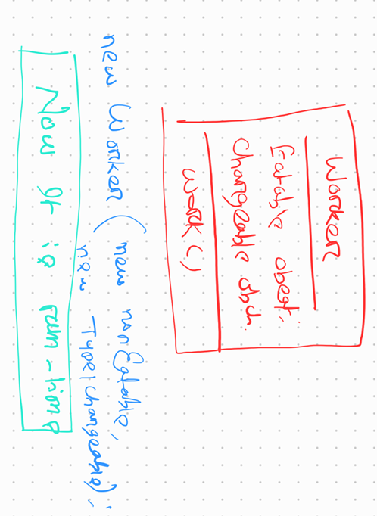
    - Here we separated the **changing** and **non-changing** part.
    - **work()** is fixed, so it is left as it is; **eatable()** and **charge()** will vary, so created interfaces for those and kept one one variable of those.
    - Now, while creating worker object, the client can give which type of object he want, now no more redundent code, its clean and no inheritance hell.
  + F

**Factory Design Pattern**

* Object creation logic and Business logic should be kept separated; Factory design pattern creates objects and supply those.
* 3 types:
  + **Simple Factory**
  + **Factory Method**
  + **Abstract Factory Method**
* **Simple Factory**
  + Standard UML of Simple Factory
    - 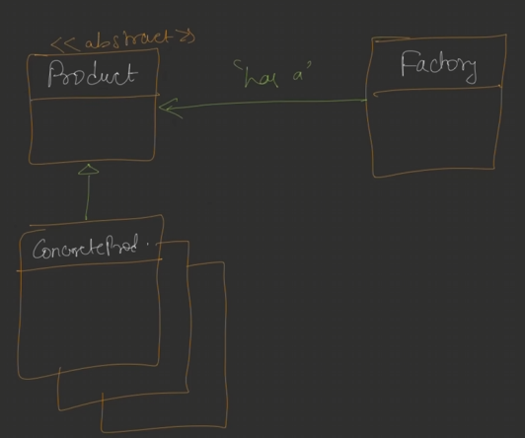
  + 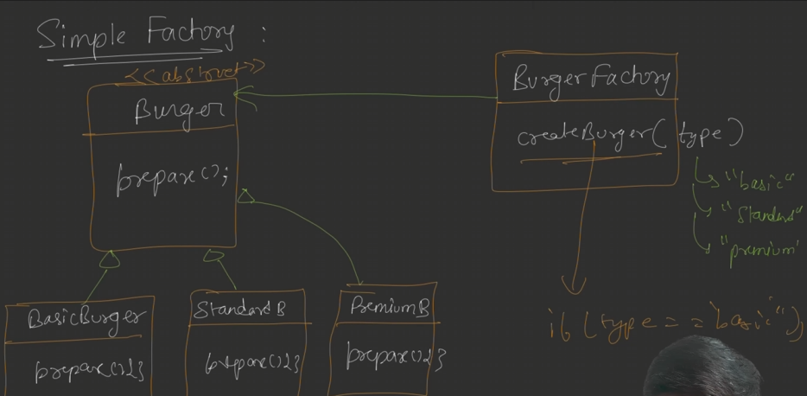
  + Here, we have one interface **Burger** and the classes are implementing this for different types of burgers.
  + ***BurgerFactory*** is a factory class then create the objects according to the type .
  + 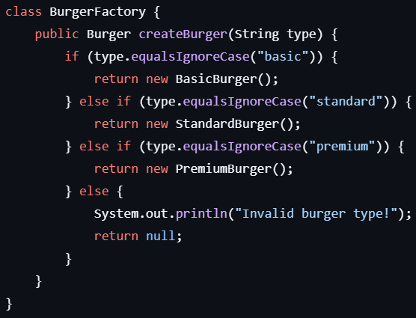
  + In this case, if one new type of burger comes then we need to edit the BurgerFactory class which violates OCP of SOLID principle.
  + Also, here only one factory is there.
  + The below is the use of Simple Factory
    - 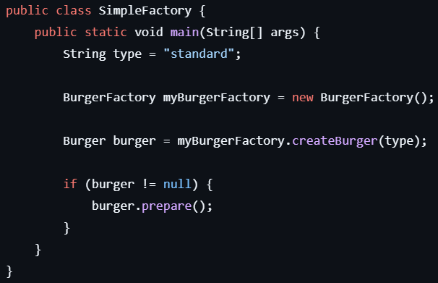
* **Factory Method**
  + Simple UML
    - 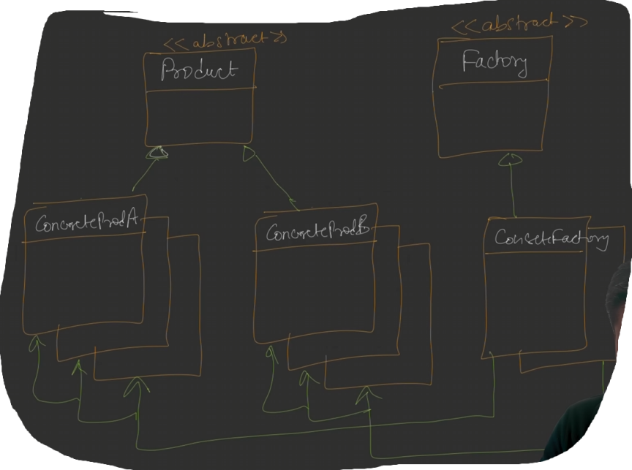
  + Defines an interface for creating Objects but allows subclasses to decide which class to instantiate.
  + In the Simple Factory, we had only one factory which was ***BurgerFactory***, imagine this as a franchise.
  + If multiple franchise are there who makes different types of burgers then it’ll break.
  + Lets say there are some **6** types of burgers, and 2 franchise there, each make 3 types of burgers out of those 6.
  + So, to implement this, we need to make BurgerFactory as abstract and create new factory classes implementing this.
  + 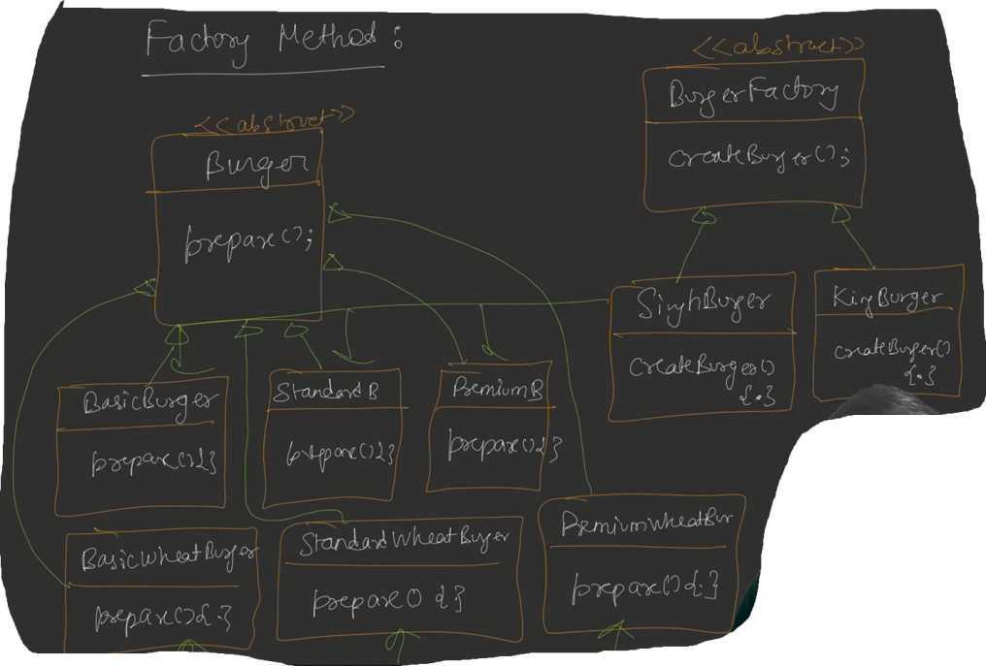
    - Here we have to BurgerFactory, *SinghBurger* and *KingBurger;* 
      * *SinghBurger* makes Basic, Standard, Premium burgers;
      * SinghBurger makes BasicWheat, StandardWheat, PremiumWheat burgers.
  + 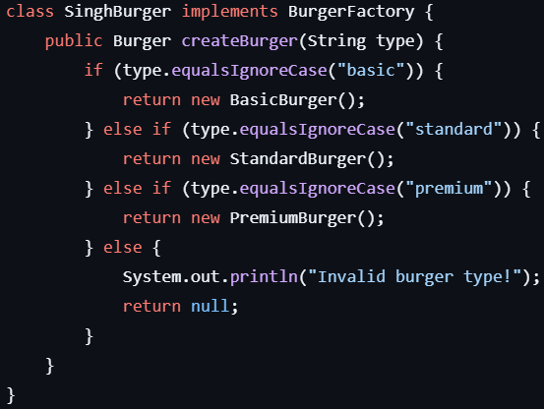
  + 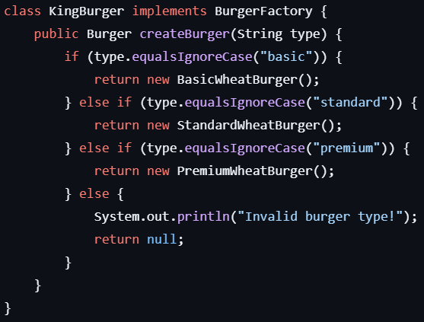
  + The below is the use of **Factory Method** classes.
    - 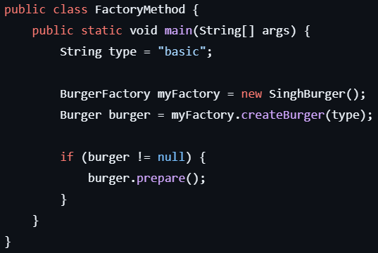
* **Abstract Factory Method**
  + Till now, the factory was only creating one type of objects which was “Burger”. But in real world, it needs to create different types of objects.
  + Provides an interface for creating families of related objects without specifying their concrete classes.
  + 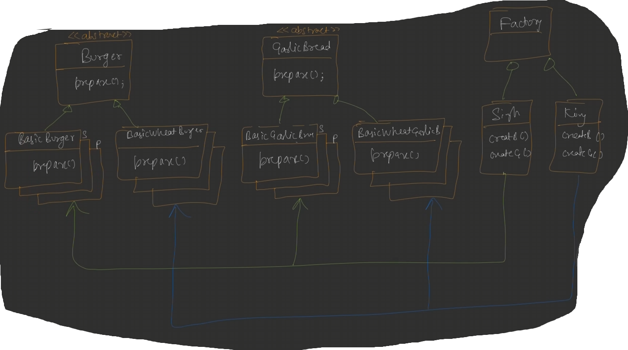
  + Nothing difference, before the factory classes were having only one method to create Burger type of objects, not it’ll be having one more method to create GarlicBread objects as well.
  + Here the factory method will contain 2 methods:
    - 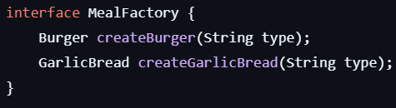
  + 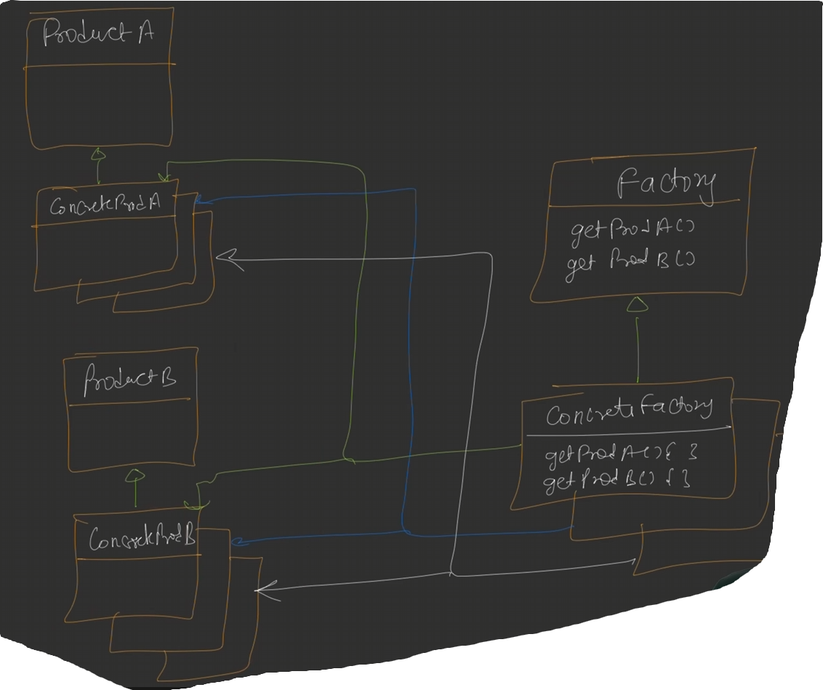
  + Example: **Notification System**
    - 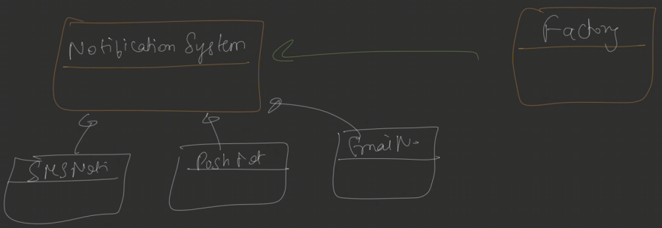
    - Here you might be thinking, why not using ***Strategy Design Pattern*** here, we can assume notification system as a strategy.
      * 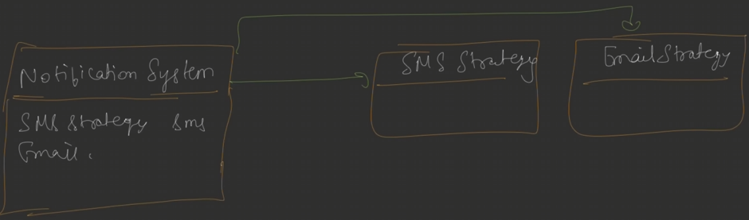
    - In this case think like this:
      * **If I want to vary algorithm during run time : Strategy Design Pattern**
        + In this case we can assume the objects are already created somewhere.
      * **If I want to separate object creation logic : Factory Design Pattern**
* **Example**
* **Products**
  + **Abstract** **Products**
    - 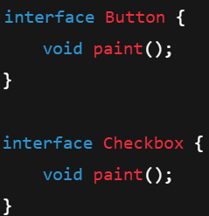
  + **Concrete Products**
    - 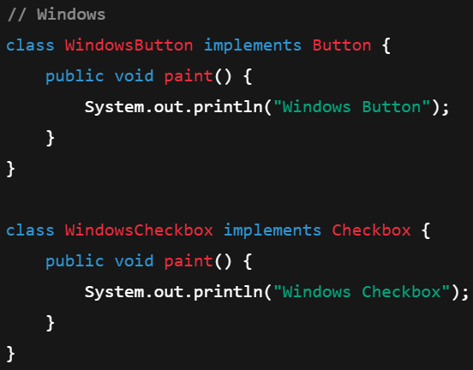
    - 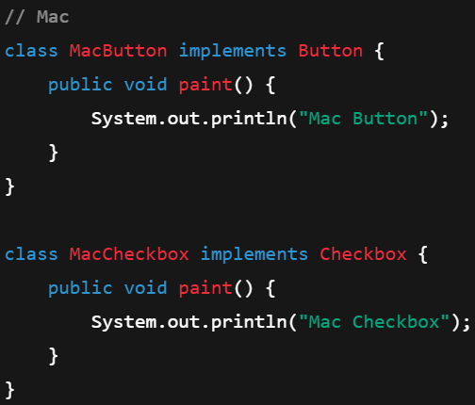
* **Factories**
  + **Abstract Factory**
    - 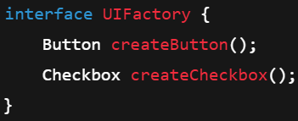
  + **Concrete Factories**
    - 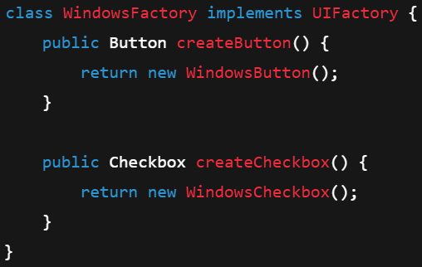
* **Client**
  + 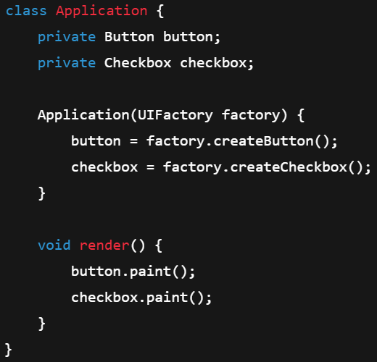
* **Usage**
  + 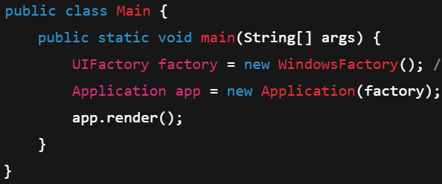
* F
* F
* F
* F
* F

**Singleton Design Pattern**

* Only one object is created from a class and that object is used throughout the application.
* Steps to create a singleton class:
  + First make the constructor private, now object cannot be created with **new** keyword.
  + Now create a static variable to keep the instance, and a method to return that instance.
  + 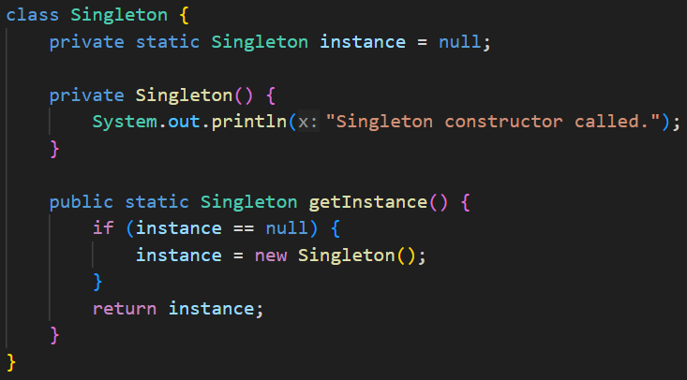
    - **Problem:** **This one is not thread-safe, i.e. if 2 threads call this getInstance() method at same time, then 2 instances will be created.**
  + --------------- OR ---------------
  + 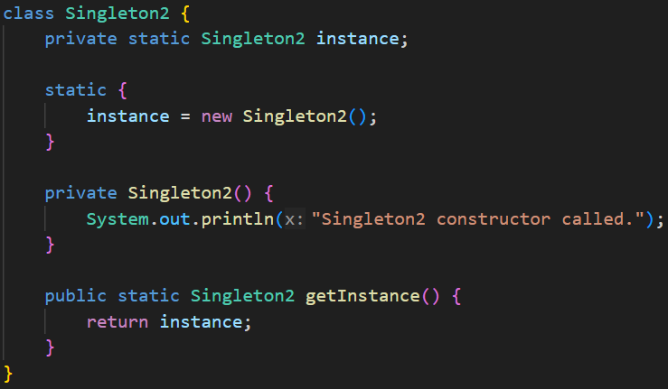
    - You can use **static block** in Java.
    - **Problem:** **No lazy loading; it is thread safe, but even if the object is not required, the object will be created in this case.**
* **Thread-safe Singleton Implementation**
* Lock the **getInstance()** method
  + 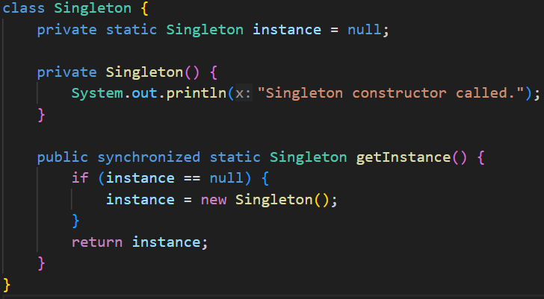 (**synchronized** is used to lock)
  + **Problem:** **even after the instance is created, multiple threads can not call this method at same time.**
  + Only first time, when the instance is not created, only one call should happen; after that multiple threads can call this method at same time; it’ll not cause any problem.
  + So, we should not apply **lock** on the method itself.
* Lock only the *instance creation part inside if block* (lock should be applied on **Class** level)
  + 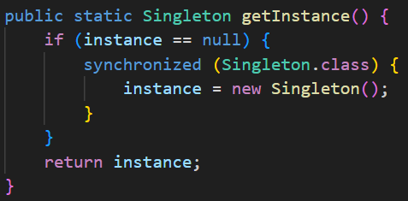 ❌
    - (**synchronized** not there at method level)
  + It looks fine, but there is a big problem here.
  + **Problem**:
    - Lets say **T1** and **T2** (2 threads) call the **getInstance()** method at same time.
    - As the method is not locked, both can enter inside the *if* block.
    - Lets say **T1** applied the lock, so now **T2** has to wait till **T1** is release the lock.
    - So now, after **T1** is done, one instance will be created and stored.
    - Now, **T2** was waiting inside that *if*  block. So, after **T1** releases the lock **T2** will again create that instance.
    - So, now 2 instances got created in place of 1
  + We need to implement another check inside **synchronized** block.
  + 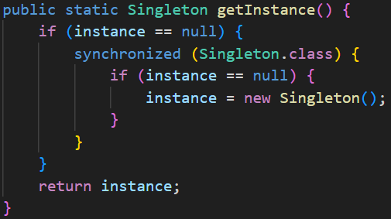 ✅
    - Now it’ll work, after **T1** releases, in **T2** it’ll again check if instance is null, as **T1** already created the instance so it’ll not create again.
* **Real World use-cases**
  + Logging systems
  + Database connections
  + Configuration manager

**Design a Food Delivery App**

* Requirements
  + Functional requirements:
    - User can search for restaurants based on location
    - User can add items to cart
    - User can checkout by making payment
    - User should be notified once order is placed successfully
  + Non-Functional requirements:
    - Each part of design should be scalable and modifiable
* Happy flow:
  + 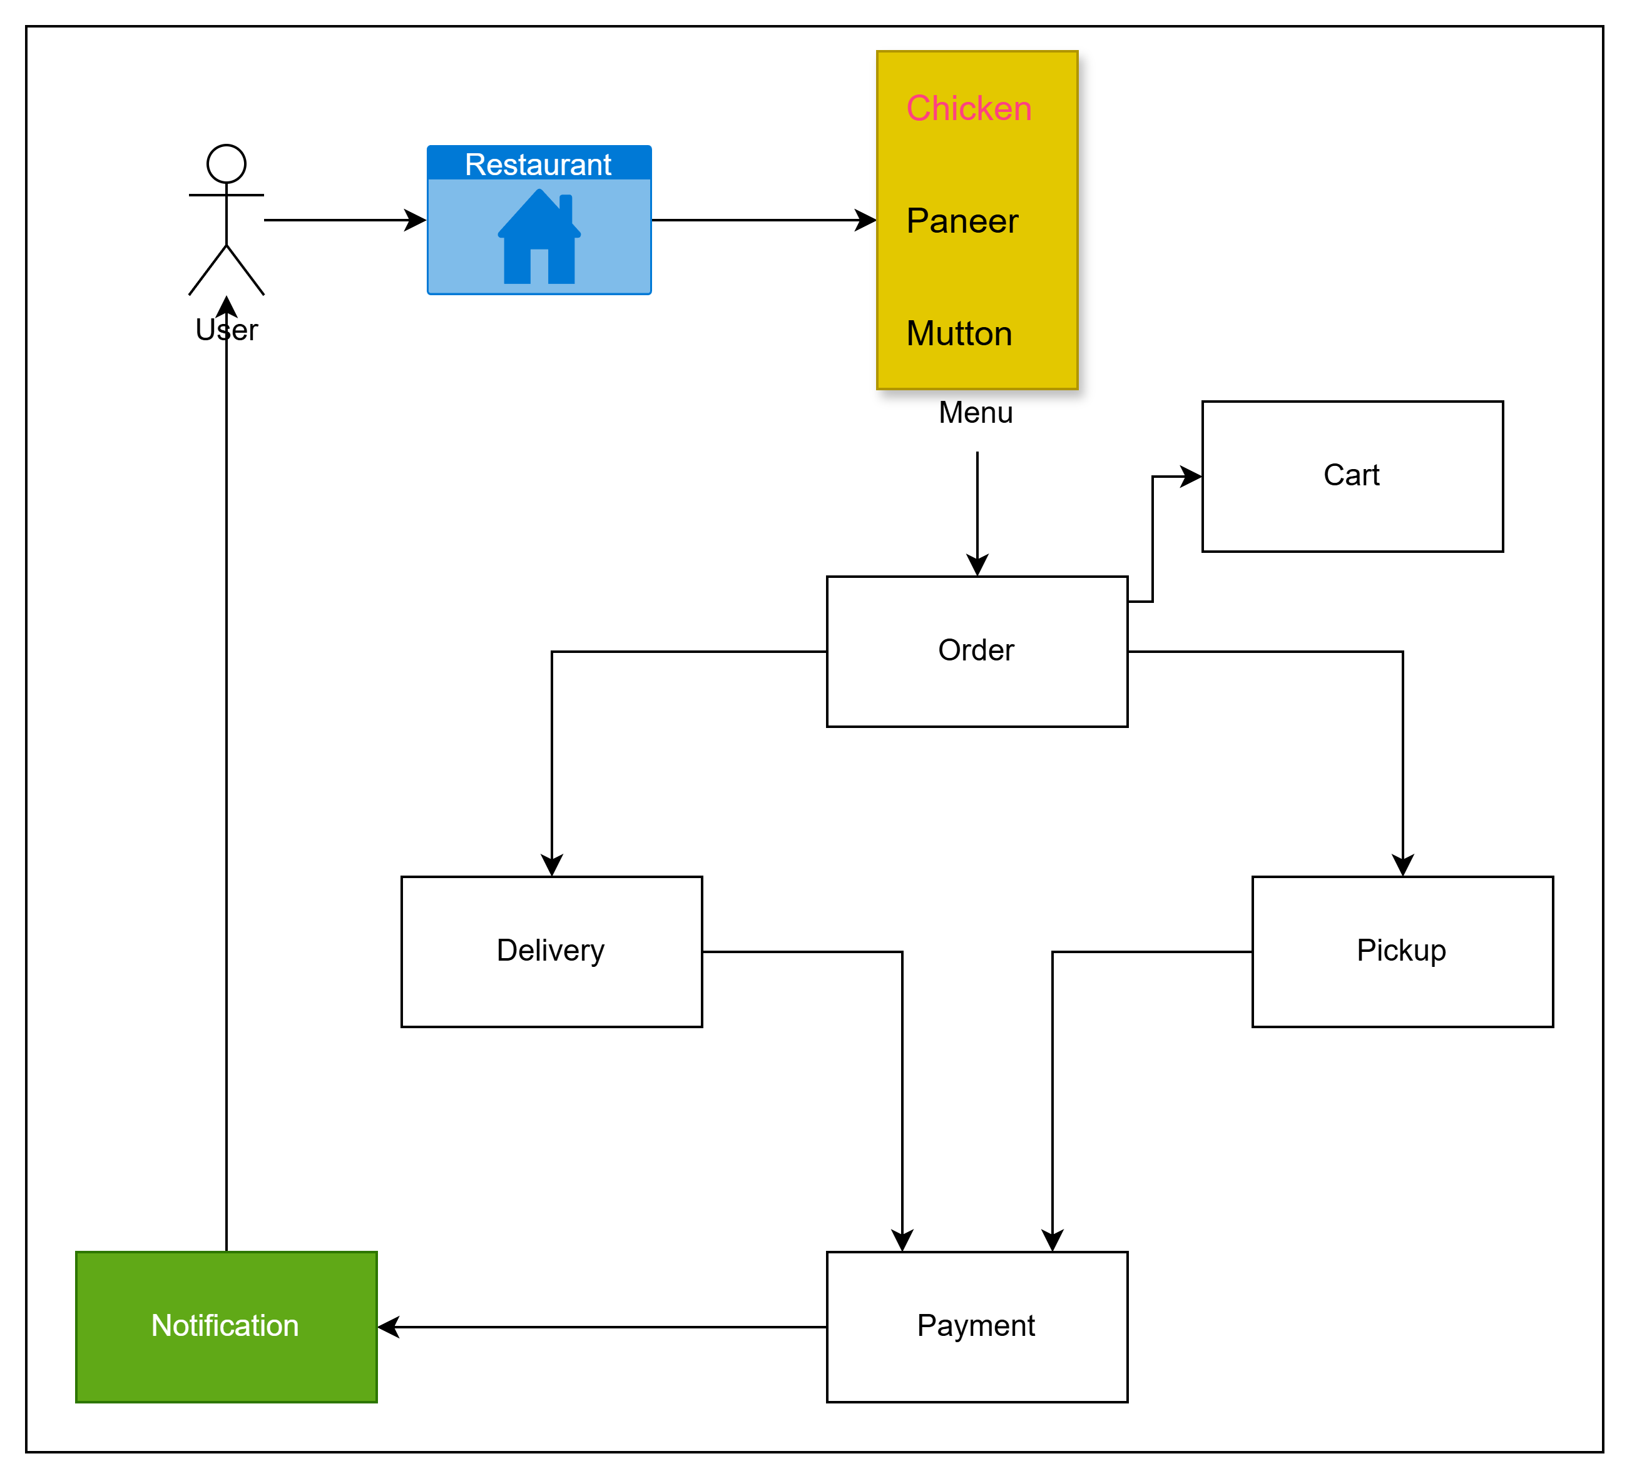
* UML diagram (“Tomato” is the name of the App):

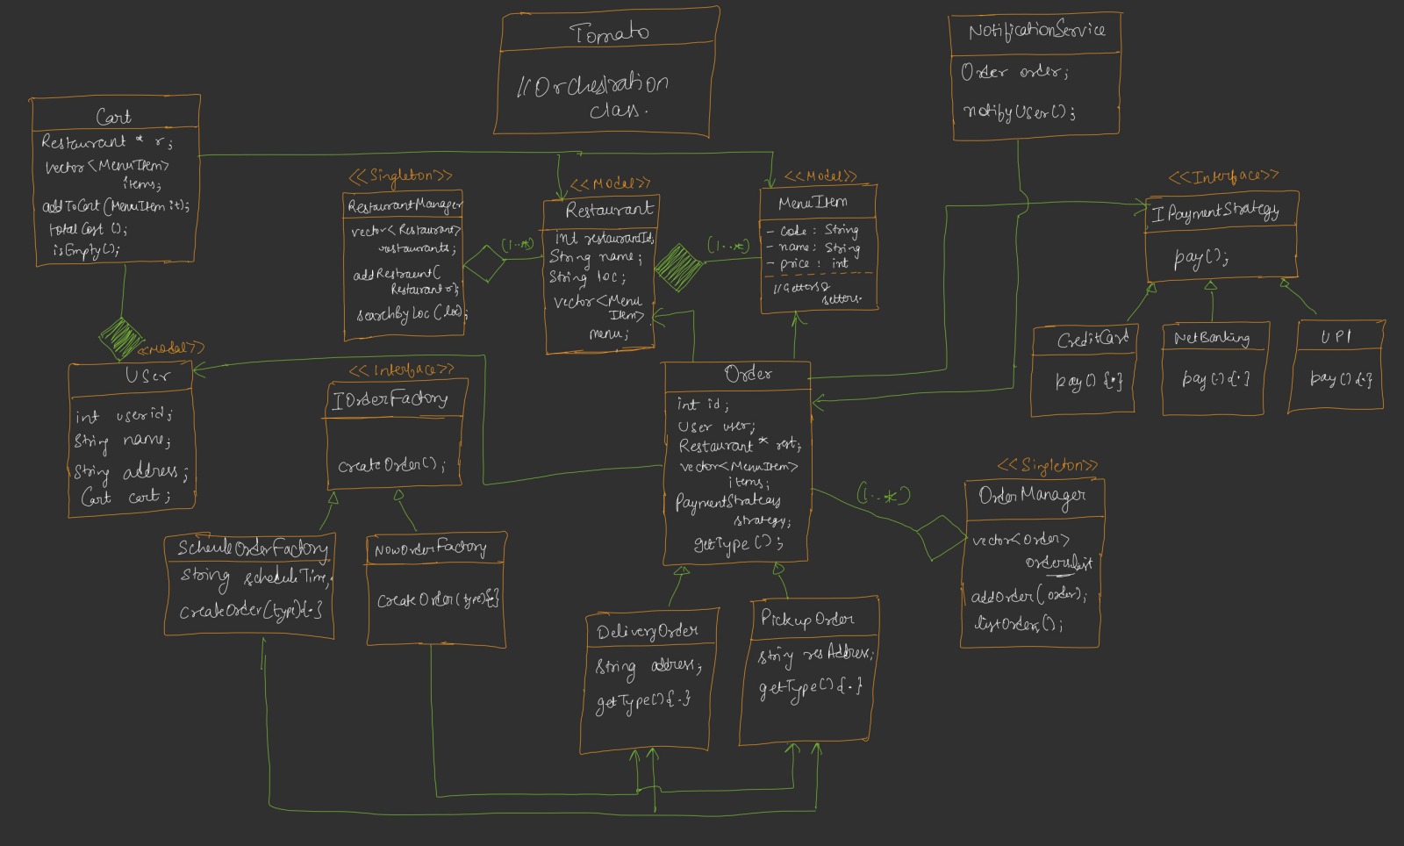

* + Here we have assumed, Menu item doesn’t exist without Restaurant, so it’s a ***composition*** relation.
  + **<<model>>** means kind of Entity, which have getters and setters.
  + No one should talk to **Restaurant** directly, he has to talk to **RestaurantManager** to access Restaurants. So, it’ll make a **loose coupling**.
  + One **RestaurantManager** should be there in whole application that manages the list of restaurants and rest. So, it is better to make is **<<Singleton>>**.
  + Now, **User** which will be having ***composition*** relationship with **Cart**, cart will not exist without user.
  + **Cart** to **Restaurant**, one-to-one relationship (empty cart can be present, so aggregation).
  + **Cart** to **MenuItem**, one-to-many relationship (empty cart can be present, so aggregation).
* F
* F
* F
* F
* F
* F
* F

**Observer Design Pattern**

* Description
  + In this design pattern, 2 types of things are there:
    - **Subject**
    - **Observer**
  + Subject to Observer: **one-to-many** relationship.
    - A single **subject** can be observed by multiple **observers**.
  + Here, Observer observe the Subject if any state changes happens in the Subject.
  + The following ways are possible:
    - The observer will ask the subject if any state change happened repeatedly, and the subject will send response; then observer will get to know about the state change.
      * But this is very time consuming, and too much calls are there.
    - Other way is, **subject** keeps track of all of its **observers** and notifies those if any state change happens. This is the actual case in Observer Design Pattern.
* Defines a one-to-many relationship between objects so that when one object changes state, all of its dependents are notified and get updated automatically.
* UML Diagram
  + 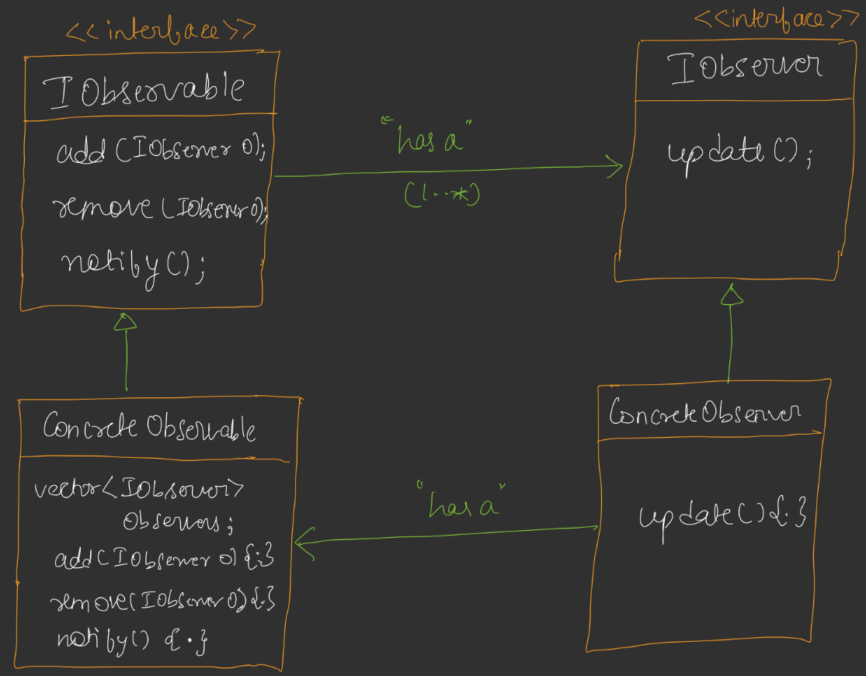
* Flow:
  + Subject (Observ**able**) contains a ***notify()*** method (name can be different) which calls the **update()** method of each *observer*.
  + **update()** method inside the Observer calls the **getValue()** method (can be different name) from the *Subject*to get the latest state.
  + In below example,
    - notify() ----------> notifyObservers()
      * Its calling **update()** method of Observer
    - update() -----------> update()
      * Its calling **getNews()** method of Subject
    - getValue() ----------> getNews()
      * Its returning the latest state value
* Example
  + Observer
    - 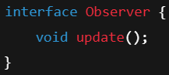
    - 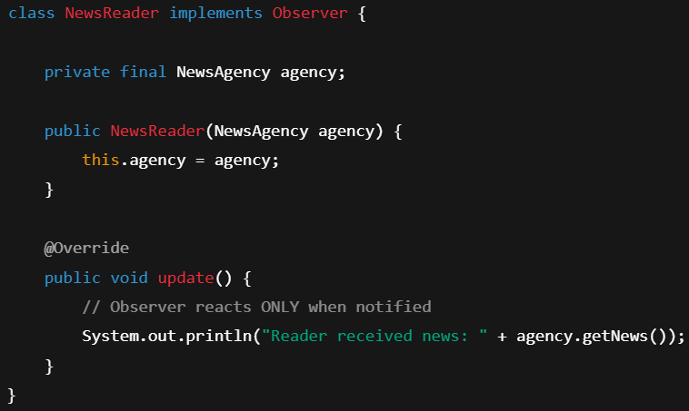
  + Subject
    - 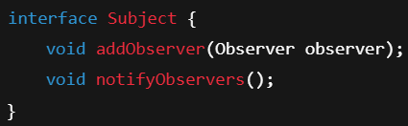
    - **notifyObservers()** is the method which notifies for each state change.
    - 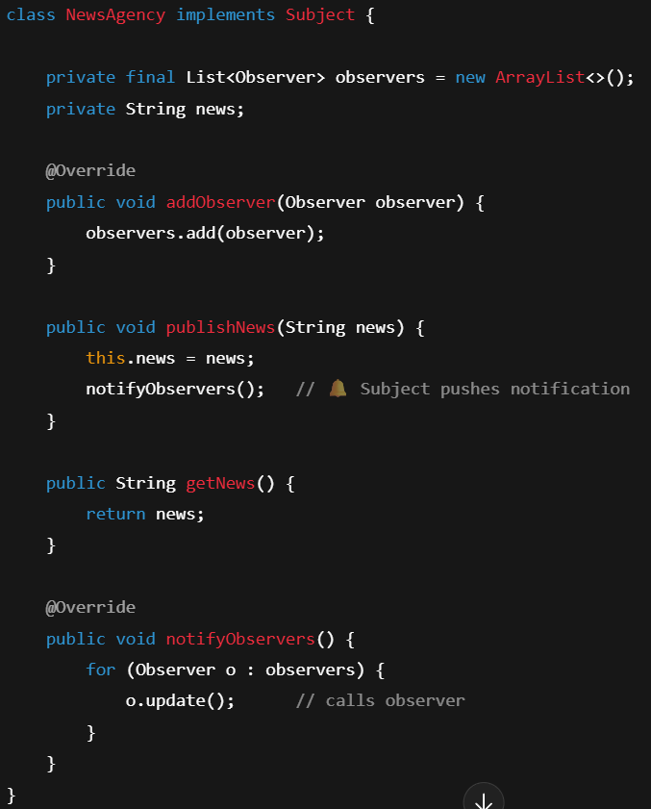
  + **Client**
    - 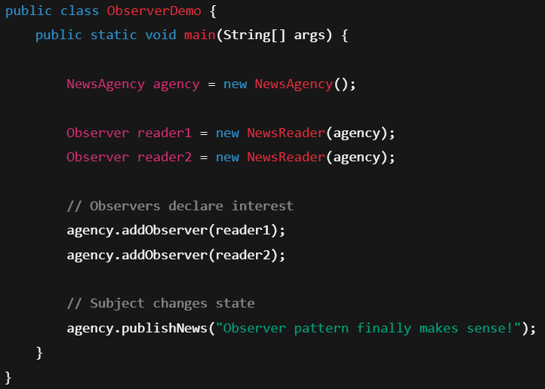
* F
* F
* F
* F
* F
* F